Name: | Index No.: | CT Group: 09

PIONEER JUNIOR COLLEGE, SINGAPORE

JC2 PRELIMINARY EXAMINATIONS
HIGHER 2

CHEMISTRY 9647/01
9746/01

Paper 1 Multiple Choice 21 September 2010

1 hour

Additional Materials: Multiple Choice Answer Sheet
Data Booklet

READ THESE INSTRUCTONS FIRST

Write in soft pencil.
Do not use staples, paper clips, highlighters, glue or correction fluid.
Write your name, Centre number and index number on the Answer Sheet in the spaces provided unless this has been done for you.

There are forty questions on this paper. Answer all questions. For each question there are four possible answers A, B, C and D.
Choose the one you consider correct and record your choice in soft pencil on the separate Answer Sheet.

Read the instructions on the Answer Sheet very carefully.

Each correct answer will score one mark. A mark will not be deducted for a wrong answer.
Any rough working should be done in this booklet.

This document consists of 14 printed pages.

Pioneer Junior College
Section A

For each question, there are four possible answers labelled A, B, C and D. Choose the one you consider to be correct.

1 | Sodium hydrogen carbonate, NaHCO₃, can be prepared from sodium sulfate by a three-step process.  Na₂SO₄(s) + 4C(s) → Na₂S(s) + 4CO(g)  Na₂S(s) + CaCO₃(s) → CaS(s) + Na₂CO₃(s)  Na₂CO₃(s) + H₂O(l) + CO₂(g) → 2NaHCO₃(s)  What is the mass of sodium hydrogen carbonate, to the nearest kg, that could be formed from 100 kg of the sodium sulfate, assuming a 90% yield in each step?
1 | A | 146 kg | B | 122 kg | C | 94 kg | D | 86 kg

2 | A chloride of a Group V element has the formula MCl₃. When 0.100 g of MCl₃ was added to water and the resulting solution titrated with 0.0500 mol dm⁻³ silver nitrate, it was found that 33.0 cm³ of aqueous silver nitrate was needed to precipitate all the chloride ions.  What is the identity of M?
2 | A | N | B | P | C | As | D | Sb

3 | The nickel-cadmium rechargeable battery is based upon the following overall reaction.  Cd + 2NiO(OH) + 4H₂O → Cd(OH)₂ + 2Ni(OH)₂·2H₂O  What is the oxidation number of nickel at the beginning and the end of the reaction?
3 |  | beginning | end
3 | A | +1.5 | +2
3 | B | +2 | +3
3 | C | +3 | +2
3 | D | +3 | +4
4 | How many different orbitals are there in the 3s, 3p and 3d sub-shells respectively?
4 | A | 1, 3, 5
4 | B | 1, 4, 9
4 | C | 2, 6, 10
4 | D | 2, 8, 18

5 | Which of the following species is not planar?
5 | A | C₂Cl₄ | B | ICl₄ – | C | PCl₄⁺ | D | XeF₄

6 | Under what conditions would a gas at low pressure behave more ideally?
6 | A | Molecules at low temperature colliding elastically.
6 | B | Molecules at high temperature colliding elastically.
6 | C | Molecules at low temperature colliding non-elastically.
6 | D | Molecules at high temperature colliding non-elastically.

7 | A possible way of preparing hydrogen peroxide is through the following sequence of reactions.  H₂(g) + ½O₂(g) → H₂O(l) ∆H^{θ} = x  H₂O(l) + ½O₂(g) → H₂O₂(l) ∆H^{θ} = y  Which expression can be used to calculate the enthalpy change for the following reaction?  H₂O₂(l) → H₂(g) + O₂(g)
7 | A | – x – y | B | x + y
7 | C | – x + y | D | x – y

8 | A current was passed through two cells connected in series. The first cell contained molten magnesium chloride while the other contained molten chromium(III) chloride. The first cell produced 4.8 g of magnesium.  What is the mass of chromium produced by the other cell?
8 | A | 2.4 g | B | 3.2 g | C | 6.8 g | D | 15.6 g

9 | For which equilibrium is K_{c} = K_{p}?
 | A | C(s) + H₂O(l) CO(g) + H₂(g)
 | B | H₂(g) + I₂(g) 2HI(g)
 | C | N₂(g) + 3H₂(g) 2NH₃(g)
 | D | 2NO₂(g) N₂O₄(g)

10 | Which statement concerning the equilibrium reaction given below is correct?  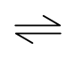  2CrO₄^{2–}(aq) + 2H⁺(aq) Cr₂O₇^{2–}(aq) + H₂O(l)
 | A | A redox reaction is taking place.
 | B | The equilibrium constant, K_{c}, has no units.
 | C | A decrease in pH will result in an increase in the concentration of Cr₂O₇^{2–}(aq) and the colour intensity of the orange solution increases.
 | D | The addition of a catalyst will result in an increase in the concentration of Cr₂O₇^{2–}(aq) and the colour intensity of the orange solution increases.

11 | The numerical values of the solubility product of calcium carbonate and calcium fluoride are 8.7 x 10⁻⁹ and 4.0 x 10⁻¹¹ respectively at 25 ºC.  Which of the following statements is true?
11 | A | Calcium carbonate has a higher solubility than calcium fluoride.
11 | B | Addition of sodium fluoride to a solution containing calcium fluoride decreases the solubility product of calcium fluoride.
11 | C | Addition of sodium fluoride to a saturated solution of calcium fluoride increases the solubility of calcium fluoride.
11 | D | Addition of calcium nitrate to a solution containing fluoride ions and carbonate ions both 1 mol dm⁻³, causes calcium fluoride to precipitate out first.

12 | The rate of removal of the pain-killing drug paracetamol from the body is a first order reaction with a rate constant, k = 0.26 h⁻¹.  How long will it take for 25% of the paracetamol to remain in the body?
12 | A | 2.3 h | B | 2.7 h | C | 5.3 h | D | 8.0 h

13 | Iodine and propanone reacts in presence of acid as catalyst is shown below.  CH₃COCH₃ + I₂ ⎯→ CH₂ICOCH₃ + HI  Given that rate = k [CH₃COCH₃] [H⁺], which of the following statement is correct?
13 | A | The rate determining step does not involve hydrogen ions.
13 | B | The yield of product is independent of the concentration of iodine.
13 | C | The rate of reaction is higher if the concentration of iodine is increased.
13 | D | The rate constant, k, remains constant if the concentration of all reactants is increased.

14 | Which one of the following is a correct statement about aluminium?
 | A | It forms amphoteric chlorides.
 | B | It forms an oxide that is insoluble in water.
 | C | It forms a solid oxide that sublimes at 180 ºC.
 | D | It forms oxides that can exist as dimers in the vapour phase.

15 | Which of the following properties could be predicted for strontium or its compounds?
15 | A | It does not burn in air.
15 | B | It forms a soluble sulfate.
15 | C | It reacts with cold water, liberating hydrogen.
15 | D | It forms a water-soluble carbonate which does not decompose on heating.

16 | Which of the following statements about the Group VII is correct?
16 | A | The halogens increase in oxidising power down the group.
16 | B | The K_{sp} values of the silver halides decrease down the group.
16 | C | The lattice energy of the silver halides becomes more exothermic down the group.
16 | D | The hydration energy of the gaseous halide ions becomes more negative down the group.

17 | Aqueous chlorine is added to aqueous sodium bromide and the mixture is shaken with an equal volume of trichloromethane.  Which observation would be made?
17 | A | The solution in the test-tube turns purple.
17 | B | The solution in the test-tube turns orange.
17 | C | A colourless layer forms on top of a purple layer.
17 | D | A colourless layer forms on top of an orange layer.

18 | Titanium(IV) oxide is widely used in the paint industry as a white pigment. It is soluble in hot concentrated sulfuric acid according to the equation below.  TiO₂ + H₂SO₄ → TiO²⁺ + SO₄²⁻ + H₂O  Which of the following describes the nature of this reaction?
18 | A | acid-base | B | complex ion formation
18 | C | dehydration | D | redox

19 | Which of the following is a propagation step in the reaction between propane and chlorine when they are irradiated with ultraviolet light?
19 | A | CH₃CH₂CH₂• + Cl• → CH₃CH₂CH₂Cl
19 | B | CH₃CH₂CH₂Cl + Cl• → CH₃CH₂CH₂• + Cl₂
19 | C | CH₃CH₂CHCl• + Cl₂ → CH₃CH₂CHCl ₂ + Cl•
19 | D | CH₃CH₂CH₂• + Cl₂ → CH₃CH₂CHCl• + HCl

20 | Fly paper is used as a non-toxic method of trapping houseflies. To increase its effectiveness, Muscalure, which is a fly pheromone, is added to the paper during its manufacture. Muscalure has the following structure.  CH₃(CH₂)₇CH=CH(CH₂)₁₂CH₃  Which of the following statement about Muscalure is not correct?
20 | A | It decolourises aqueous bromine.
20 | B | It does not rotate plane polarised light.
20 | C | It reacts with HBr(g) to give a chiral product.
20 | D | It will turn orange acidified potassium dichromate(VI) green.

21 | 3-chlorobenzoic acid can be synthesised from benzene in 3 steps.  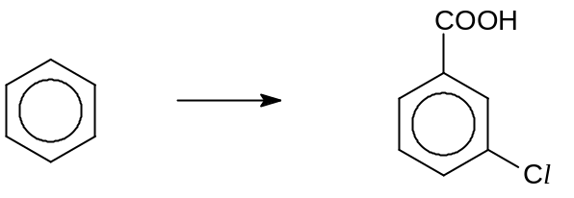  benzene 3-chlorobenzoic acid  Which of the following is the best method for this synthesis?
21 |  | Step I | Step II | Step III
21 | A | CH₃Cl, FeCl₃ | MnO₄⁻, H⁺ | Cl₂, FeCl₃
21 | B | CH₃Cl, FeCl₃ | Cl₂, FeCl₃ | MnO₄⁻, H⁺
21 | C | Cl₂, FeCl₃ | CH₃Cl, FeCl₃, | MnO₄⁻, H⁺
21 | D | Cl₂, FeCl₃ | MnO₄⁻, H⁺ | CH₃Cl, FeCl₃

22 | The following represent a possible synthesis route from cyclohexene to 1,2-dibromohexane.  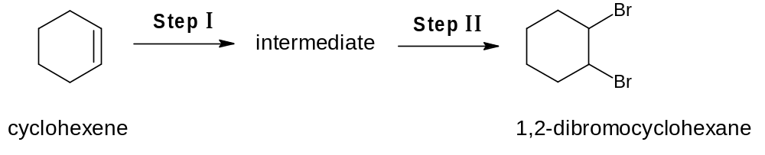  Which of the following sets of reagents and conditions will not give a good yield of 1,2-dibromohexane?
22 |  | Step I | Step II
22 | A | cold KMnO₄, NaOH(aq) | concentrated H₂SO₄, KBr
22 | B | cold KMnO₄, NaOH(aq) | red P, Br₂
22 | C | Br₂(aq) | red P, Br₂
22 | D | concentrated H₂SO₄, KBr | Br₂, uv

23 |  | When 0.04 mol of an organic compound F was burnt in excess oxygen, it produced 0.20 mol of water and 0.20 mol of carbon dioxide. When F was treated with alkaline aqueous iodine, a yellow precipitate was observed.  Which of the following could be F?
 |  | A |  | CH₃COCH₂CH₂CH₃ | B | (CH₃)₂C(OH)CH=CH₂
 |  | C |  | CH₃CH(OH)CH₂CH₂CH₃ | D | CH₃CO₂CH₂CH₂CH₃
24 | Ibuprofen is a powerful painkiller.  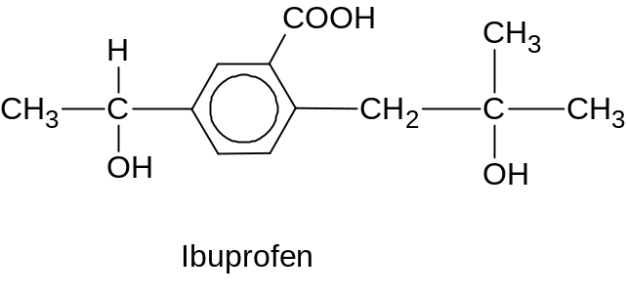  Which of the following statements about Ibuprofen is correct?
24 | A |  | 1 mol of Ibuprofen can evolve 3 mol of H₂.
24 | B |  | 1 mol of Ibuprofen reacts with 2 mol of HCl.
24 | C |  | The bond angle around all carbon atoms is 109.5º.
24 | D |  | It will decolourise aqueous bromine to give a white precipitate.

25 | The table shows the results of simple tests on a compound H.  From the results of the tests, what could H be?
  Reagents | Observations
  Acidified KMnO₄(aq), heat | Purple solution turned colourless.  Effervescence observed.
  Fehling’s solution | No brick-red precipitate
  Tollens’ reagent | Silver mirror observed
 | A | 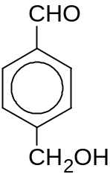 | B | 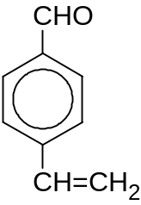
 | C | 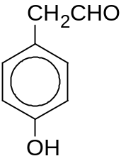 | D | 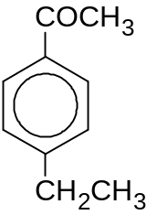

26 | Esters can be converted to alcohols using lithium aluminium hydride followed by the addition of water.  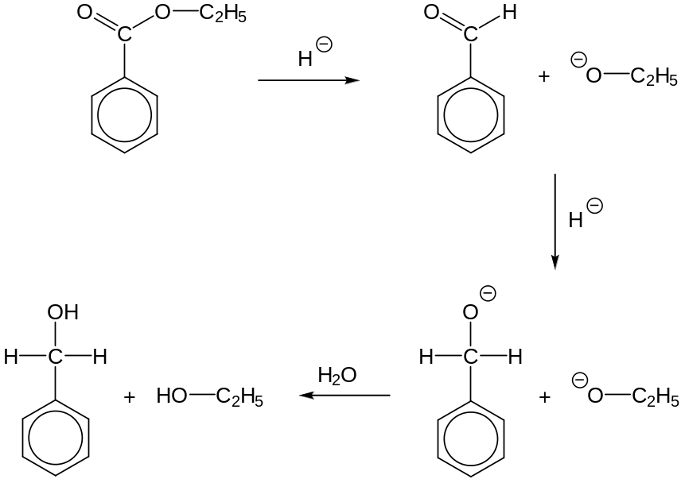  Which of the following reaction does not occur in this process?
26 | A | condensation | B | nucleophilic addition
26 | C | hydrolysis | D | nucleophilic substitution

27 | Which sequence shows the correct order of increasing ease of hydrolysis of the following compounds?  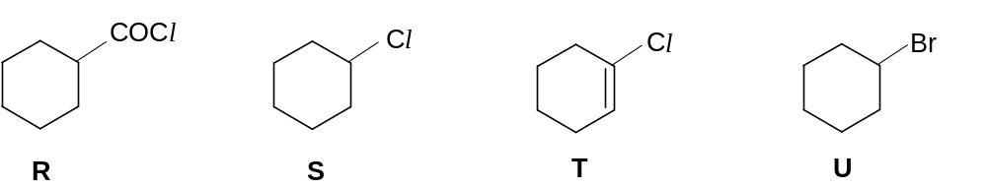
27 | A | T < U < S < R
27 | B | T < S < U < R
27 | C | R < S < U < T
27 | D | R < U < S < T

28 | Which of the following represents the correct sequence of increasing pK_{a} value of the four acids?
28 | A | CCl₃CO₂H < CH₃CO₂H < C₆H₅OH < C₂H₅OH
28 | B | CCl₃CO₂H < CH₃CO₂H < C₂H₅OH < C₆H₅OH
28 | C | C₆H₅OH < C₂H₅OH < CCl₃CO₂H < CH₃CO₂H
28 | D | C₆H₅OH < C₂H₅OH < CH₃CO₂H < CCl₃CO₂H

29 | When aqueous bromine is added to a solution of phenylamine, the reddish brown colour of bromine disappears. Which of the following statements is true?
29 | A | The resultant solution is more basic.
29 | B | Nucleophilic substitution reaction has taken place.
29 | C | Bromine forms a colourless complex with phenylamine.
29 | D | Br atom is substituted at the 2, 4 and 6- positions with respect to –NH₂ group.

30 | Alanine is a naturally occurring amino acid. Which of the following statements about alanine and 3-aminopropanoic acid is not correct?  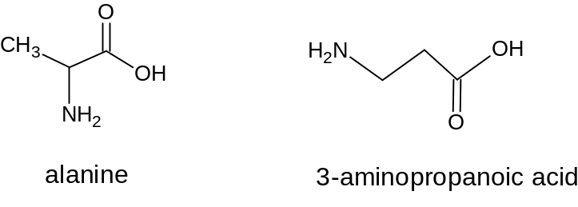
30 | A | Alanine and 3-aminopropanoic acid are structural isomers.
30 | B | Alanine has a higher melting point than 3-aminopropanoic acid.
30 | C | Both compounds are able to react with ethanoic acid to give amide.
30 | D | Both compounds in their aqueous solutions are able to act as buffers.

Section B

For each of the questions in this section, one or more of the three numbered statements 1 to 3 may be correct.

Decide whether each of the statements is or is not correct (you may find it helpful to put a tick against the statements that you consider to be correct).

The responses A to D should be selected on the basis of

A | B | C | D
1, 2 and 3 are correct | 1 and 2 only are correct | 2 and 3 only are correct | 1 only is correct

No other combination of statements is used as a correct response.

31 Which molecules have the correct shapes?

1 | SF₆ is octahedral.
2 | SF₄ is see-saw.
3 | SF₂ is linear.

32 In monopropellant engines, one of the manner in which hydrazine, NH₂NH₂, is decomposed is as shown.

3NH₂NH₂(l) → 4NH₃(g) + N₂(g)

Which of the following expression can be used to calculate the above enthalpy change?
[Note: ∆H^{θ}_{f} represents enthalpy change of formation, ∆H^{θ}_{c} represents enthalpy change of combustion and BE represents bond energy.]

1 | 3∆H^{θ}_{c}(NH₂NH₂(l)) – 4∆H^{θ}_{c}(NH₃(g)) – ∆H^{θ}_{c}(N₂(g))
2 | 4∆H^{θ}_{f}(NH₃(g)) – 3∆H^{θ}_{f}(NH₂NH₂(l))
3 | 3BE(N-N) – BE(N≡N)

33 What are the conditions usually quoted for the standard electrode potential of hydrogen to be 0.00 V?

1 | The concentration of H⁺(aq) is 1 mol dm⁻³.
2 | The atmospheric pressure is exactly 1 atm.
3 | The temperature is 0 ºC.

34 Some data on two acid-base indicators are shown below.

Indicator | Approximate pH range | Colour change
Indicator | Approximate pH range | Acid | Alkali
bromocresol green | 3.8 – 5.5 | yellow | blue
phenol red | 6.8 – 8.5 | yellow | red

Which one of the following conclusions can be drawn about a solution in which bromocresol green is blue and phenol red is yellow?

1 | It is weakly acidic.
2 | It can be a solution of ammonium sulfate.
3 | It can be a solution of sodium ethanoate.

35 Anhydrous barium nitrate and anhydrous magnesium nitrate both decompose on heating, evolving nitrogen dioxide and oxygen and forming an oxide. Which of the following statements concerning these decompositions are correct?

1 | Nitrogen dioxide is evolved at a lower temperature from magnesium nitrate than from barium nitrate.
2 | The numerical value of the lattice energy of magnesium nitrate is greater than that of barium nitrate.
3 | For both the nitrates the volume of nitrogen dioxide evolved is four times the volume of oxygen.

36 Element Y has the valence electronic configuration of 3d⁵ 4s². Which of the following are the likely characteristics of element Y?

1 | able to form coloured ions
2 | able to form complexes
3 | low melting point

37 The reaction scheme below outlines the production of 1,4-diaminobutane from compound X.
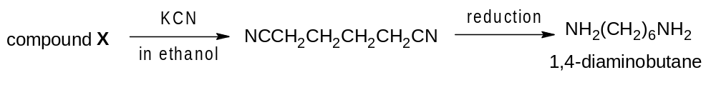
Which of the following could be compound X?

1 | BrCH₂CH₂CH₂CH₂Br
2 | HOCH₂CH₂CH₂CH₂OH
3 | CHOCH₂CH₂CHO
38 Safranal is a component of the yellow dyestuff saffron.

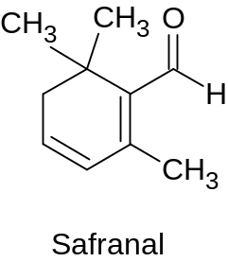

Which of the following descriptions about safranal are correct?

1 | It reacts with Tollens’ reagent.
2 | It reacts with KCN in ethanol at 10 to 20 ºC.
3 | It has all atoms lying in the same plane.

39 The three compounds P, Q, and R shown below are important flavours in citrus fruits. These compounds are much used in the food and perfume industries.

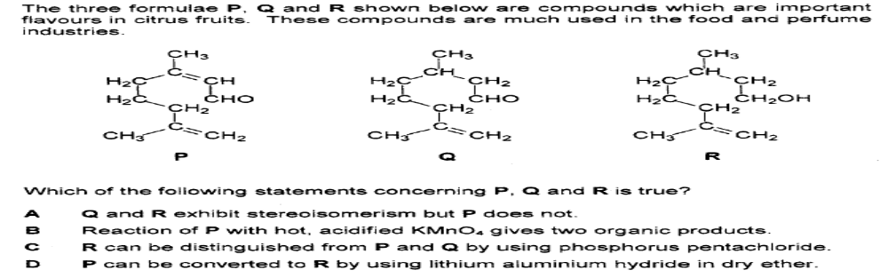

Which of the following statements are correct?

1 | Q can be converted to R by using NaBH₄ in methanol.
2 | R can be distinguished from P and Q by reacting it with sodium metal.
3 | P, Q and R form the same compound when reacted with cold aqueous KMnO₄.

40 The following shows part of a protein structure.
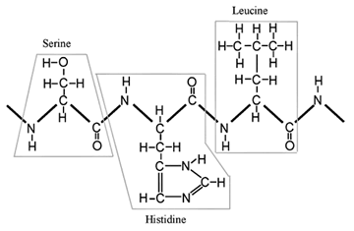

Which of the following types of interaction is responsible for maintaining the tertiary structure of the protein shown above?

1 | ionic bond
2 | hydrogen bond
3 | van der Waals’ forces

